Y O U R O F F I C E , A N Y W H E R E .
The Mesa 3 Rugged Tablet running Windows 10 offers powerful new functionality while retaining impressive features from the popular Mesa 2 Rugged Tablet. Its Quad-core Pentium processor is ready to run even the most demanding field data collection application, and its rugged ergonomic design is ready to handle a long day on the job in some of the harshest environments out there. Ready to experience Juniper Rugged?

BUILT JUNIPER RUGGED™

Meeting IP68 and MIL-STD-810G ratings, the Mesa 3 is waterproof, dustproof, and shockproof. Rest assured rain, extreme temperatures, and dirt won’t stop a productive workday.

POWERFUL PROCESSING POWER

Expect lightning-fast speeds all day long with the Mesa 3’s Quad-core Intel® Pentium N4200 processor and 8 GBs of system memory (RAM). Running a full Windows 10 OS, this device is made to handle large files and detailed maps.

ALL-DAY USABILITY

From its ergonomic enclosure to its sunlight-readable display to its 15-hour battery life, the Mesa 3 is made for long days on the job.

CAREFULLY DESIGNED AND SUPPORTED

It’s more than a rugged tablet. Designed and assembled in the United States, the Mesa 3 promises device longevity
and data protection. If it becomes necessary, each device is proudly supported by live and personalized customer support.

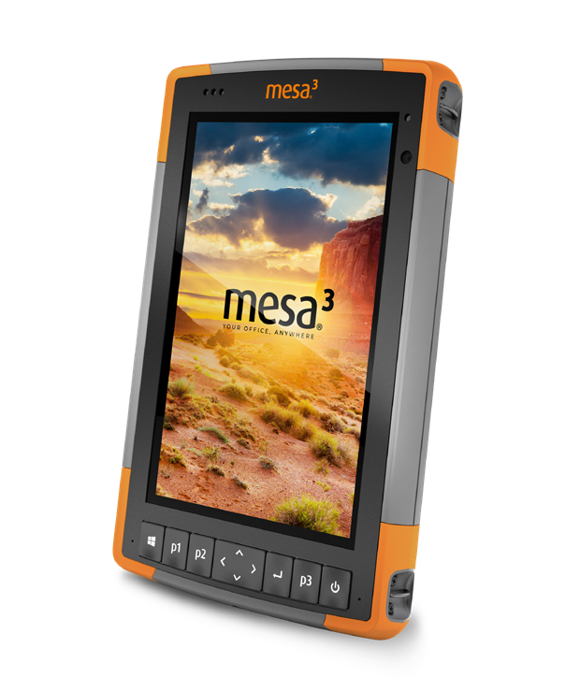

© Copyright Juniper Systems 22JUL21. All rights reserved. Specifications are subject to change without notice. All trademarks are registered or recognized by respective owners.

PROCESSOR

Designed and assembled in the United States, the Mesa Rugged Tablet provides its users with the ultimate data collection experience—wherever the job takes them. From its powerful processor to its all-day battery life to its ultra-rugged design, the Mesa 3 claims best-in-class features for anyone requiring a rugged device for mobile data collection.
Quad-core Intel® Pentium N4200

OPERATING SYSTEM AND SOFTWARE
- Microsoft® Windows 10
- Multiple languages supported (English, French, Spanish, German, Portuguese)

MEMORY
- 8 GB LPDDR4

STORAGE
- 128 or 256 GB Flash Storage, MicroSDXC card slot

WIRELESS CONNECTIVITY
- Long-range Bluetooth® Smart Ready wireless technology, v5.0 + EDR, Class 1.5, BLE support
- Wi-Fi 802.11 a/b/g/n/ac, 2.4 GHz and 5 GHz
- 2x2 MIMO
- 4G LTE multi-carrier capable

GRAPHICS
- Intel® HD Graphics

DISPLAY
- Active viewing area: 7” (178 mm)
- Resolution: WXGA (1280 x 800)
- High-visibility backlit LCD for best-in-class sunlight view-ability
- Portrait or landscape orientation with automatic screen rotation

TOUCHSCREEN
- Projected capacitive multi-touch interface for use with gloves, small tip stylus, and in wet conditions
- Optically bonded for increased visibility and strength
- Chemically-strengthened Dragontrail™ High Ion-Exchange (HIE™) cover glass for excellent impact and scratch resistance

KEYPAD
- Adjustable LED backlit keys
- Four-way directional navpad
- Windows/home key
- Power key
- Enter key
- Three user-programmable function keys
- OEM configurable/customizable

JUNIPER RUGGED™
- IP68 waterproof & dustproof
–Water: 1.4 m (4′ 7”) for 2 hours
- Operating temperature: -4 F to 122 F (-20 C to 50 C)
- Storage temperature: -22 F to 158 F (-30 C to 70 C)
- Shockproof: multiple drops from 4′ (1.2 –1.5 m) onto concrete
- Designed to meet MIL-STD-810G test procedures: Method 500.5 Low Pressure (Altitude); Method 501.5 High Temperature; Method 502.5 Low Temperature; Method
503.5 Temperature Shock; Method 506.5 Rain; Method 507.5 Humidity; Method 510.5 Sand and Dust; Method 512.5 Immersion; Method
514.6 Vibration; Method 516.6 Shock

Juniper Systems, Inc. Logan, UT, USA Phone: 435.753.1881
Email: sales@junipersys.com

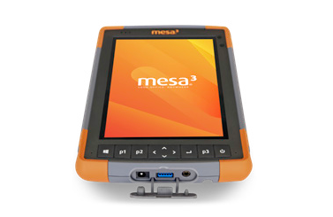
PORTS
- 12V DC power input jack
- USB 3.0 x 1
- 3.5 mm audio jack
- Optional RS-232 9-Pin D-Sub connector with 5V DC or 12V DC power output
- Docking connector (Pwr, USB 2.0, HDMI, & ethernet)
- Loud output speaker for noisy environments
- Dual digital microphone input

BATTERY
- Removable Li-Ion battery, 43.2 Whr
- Operates 8–10 hours on one charge
- Removable battery, easily changeable in field
- Optimized for strong performance in cold temperatures
- Excellent lifecycle performance
- Optional internal 21.6 Whr battery provides hot-swap capability and an additional 4–5 hours runtime

PHYSICAL
- Size: 5.40” w x 8.48” l x 1.36” d (137 x 215 x 35 mm)
- Weight: 1.5–2 lbs (680–907 g) depending on battery and expansion configuration
- Durable, chemical- and shock-resistant design
- Easy-to-grip, impact-absorbing, overmolded bumpers
- Lightweight and ergonomic design

GPS/GNSS (GEO MODELS)
- 2 to 5 meter typical accuracy
- uBlox NEO-M8N GNSS receiver and integrated antenna
- Integrated real-time SBAS receiver (WAAS, EGNOS, etc.)
- 72 GNSS tracking channels
- Optional: uBlox NEO-M8T w/post-processing capability and external GNSS antenna pass- through connection for sub-meter accuracy

BARCODE 1D/2D IMAGER (BARCODE MODELS)
- Optional built-in barcode imager and decoder
- Symbologies: all common 1D and 2D (PDF417, MicroPDF417, Composite, RSS, TLC-39, Data matrix, QR code, Micro QR code, Aztec, MaxiCode, Postal codes, etc.)
- Programmable trigger buttons
- Visible aiming bullseye with low-light illumination

Juniper Systems Ltd. Bromsgrove, UK Phone: +44 (0) 1527 870773
Email: infoemea@junipersys.com
- Barcode Connector™ utility, wedge and configuration, SDK support available

UHF RFID (RFID MODELS)
- Optional built-in UHF RFID module and internal antenna
- Region-specific frequency configurations (859–873 MHz & 915–930 MHz)
- EPCglobal Gen 2 (ISO 18000-6C) protocol support
- Wide output range (0 dBm to +27 dBm)

CAMERA (GEO MODELS)
- Rear: 8 MP with LED illumination
- Front: 2 MP

OTHER FEATURES
- Ambient light sensor
- Compass
- Accelerometer
- Gyroscope
- TPM (Trusted Platform Module) v2.0

CERTIFICATIONS AND STANDARDS
- FCC Class B
- CE Marking
- Industry Canada
- EN62368 Safety
- RoHS 2 Compliant
- Optional Class I, II, & III, Division 2, Groups A, B, C, D, F, G
- REACH
- Prop 65
- POP
- Canada Proposition
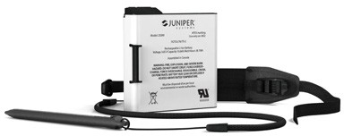
- TSCA (Toxic Substances Control Act)

STANDARD ACCESSORIES
- Standard removable battery
- AC wall charger with international plug kit
- Capacitive small-tip stylus w/tether
- Quick Start Guide
- Hand strap
- Connector port dust cover
- 2-year warranty

CUSTOMIZATION
- Available upon request

www.junipersys.com

